Industry Data and Expert Analysis (IDEA) Working Group
Summary record, Meetings 5, 6 and 7

Time: | 10am – 12noon (AEST)
Dates: | 8 December 2022, 2 February 2023, and 4 April 2023
Location: | Meeting 5 in-person in Melbourne, Meeting 6 & 7 virtual meetings, via Webex

Background

The IDEA Working Group was established in March 2022 to identify information gaps and potential solutions as well as funding and distribution models to deliver those solutions. The Working Group’s terms of reference contain 6 responsibility areas, including to establish a collection of long-term progress indicators for the Australian visitor economy.
The Working Group is comprised of 13 industry, community and government representatives and a Chair, each appointed by the CEO of the Australian Trade and Investment Commission. The IDEA Working Group was established for 12 months.
The Working Group’s first four meetings were held on 27 April 2022, 26 May 2022, 21 July 2022 and 6 October 2022. Two communiques are available for the first 4 meetings on the IDEA Working Group THRIVE 2030 web page.
The Working Group has concluded all 7 scheduled meetings and will be dissolved in May 2023 once the Working Group’s recommendations report is finalised.

Meeting content

Meeting 5
Prior to Meeting 5, a facilitation sub-committee (FSC) was formed to prepare and facilitate the day’s LIVE framework workshop. The FSC was made up of IDEA Working Group members Adele Labine-Romain, Dr Grace Pan, Carol Giuseppi and Professor Leo Jago, and was supported by Associate Professor Sarah Gardiner and Professor Susanne Becken from Griffith University. Over the 8 weeks before the meeting, the FSC developed a list of 62 potential indicators, that were grouped into 3 categories, economic, social and environmental. This was sent to the Working Group for consultation and members were asked to familiarise themselves with the list and to consider whether other indicators should be added.
At Meeting 5, the Chair took the first 5 minutes to acknowledge traditional custodians and thank the group for taking the time to meet in person. It was noted that Meeting 5 would be solely focussed on the Working Group’s responsibility to establish long-term progress indicators for the Australian visitor economy.
The Chair outlined some goals for the session were to:
- aim for a solid, if imperfect, foundation, which could be iterated and improved over time
- look for an outcome that is relevant to industry
- achieve a practical outcome that can be commenced in the near term.
The Chair then introduced the FSC. They outlined the main purpose of the workshop was to arrive at a list of prioritised indicators that could be used to monitor the visitor economy performance over time. A further goal of the workshop was to identify potential priority indicators, not to operationalise them, and further consideration could later be given to:
- whether data to measure the indicators is available, consistent and affordable
- the mix of lagging and leading indicators
- the specific ‘shape’ of the framework.
The FSC revisited Tourism 2020 indicators, targets, data sources and reporting for historical context. The group also discussed the THRIVE 2030 targets, priorities and success measures.
Group discussions noted that there was a need to monitor the balance between economic, environmental and social aspects. Other national and global developments related to climate change and general environmental awareness also pointed to a need for greater focus on tourism-specific indicators in these areas.
The Griffith Institute for Tourism drew from the Tourism 2020 and THRIVE 2030 strategies an initial list of 9 key ‘tourism aspirations’ that were presented to the Working Group. These were to be considered when prioritising the indicators. They were:
- International competitiveness
- Investment in tourism infrastructure
- Secure and resilient workforce, including First Nations participation
- High-quality products, including First Nations experiences
- Sustainable tourism benefits for communities
- Low carbon and resource efficiency
- Meeting visitor needs
- Driving innovation and productivity
- Protecting and enhancing natural and cultural heritage.
The Working Group then discussed each of the indicators at length. They focused on indicators within each of the 3 pillars (economic, social and environmental) separately and ranked them in order of priority in high, medium and low categories. Members also added further indicators to be considered and ranked by the wider group. A list of over 70 indicators was ranked as an outcome of this exercise.
In conclusion, the Chair thanked the group for their enthusiasm and achievements during the exercise, and the FSC for facilitating the workshop. The results would be synthesised for the purpose of consulting within government and industry.

Meeting 6
The Chair acknowledged traditional custodians and thanked members for their continued support and attendance at the meetings. The Chair raised 3 matters in the introduction.
- The voluntary administration of the firm Big Village Australia, which conducts Tourism Research Australia (TRA)’s National Visitor Survey and International Visitor Survey. So far, TRA data deliveries had not been impacted and a trade sale was intended.
- The Working Group’s may wish to consider if it wishes to include a recommendation in its final report that the indicators framework be adopted or included in any THRIVE 2030 re-cast process next year. There was some support shown from members. The Chair asked members to continue to consider this for further discussion at the final meeting.
- A simple online survey would be distributed to members after the final meeting in April to assess TRA’s collaboration effort during the Working Group’s tenure.
The Chair noted that since Meeting 5 there had been suggestions for further amendments to the prioritised indicators. Those proposed amendments had been distributed to members before the meeting and were presented on the screen. The Chair sought input on whether any information was missing or misrepresented. No issues were noted.
The Chair then asked a broader strategic question about how to present the indicators in the final recommendations report. Three options were put forward for discussion:
- Present all the indicators, in high-medium-low groups, potentially with a list of ranking criteria.
- Present a significantly shorter list, around 12, within a preferred framework setting – an example ‘conceptual framework’ was shared.
- Present a condensed list with more than 12 and less than 75 recommended indicators.
Members supported moving to a shorter list rather than the full set and also agreed that 12 items felt too narrow and minimalist to be representative. There was consensus that option 3 was preferred. There was also support for indicators to be presented in a format such as the ‘conceptual framework’ example shown (Attachment A).
A member suggested including indicators that had regular statistics available (for example, updated on a quarterly basis). Regularly changing statistics or indicators would present a more contemporary perspective that could assist with real-time decision making. Other members agreed but also pointed out that some metrics are likely to be equally useful, even if not frequently updated, for their general awareness-raising potential.
One member commented that the prioritised indicators need further consideration. The Chair noted that consultation on the proposed indicators and framework was already underway and noted the following entities as consultation parties: industry bodies, ASCOT sustainability planning sub-committee, sustainability and net zero federal government bodies, the Tourism Research Committee (the data and research sub-committee of ASCOT), as well as with the THRIVE Implementation Advisory Group (government and industry).
The Chair asked members to consider if other specific entities should be consulted and to pass suggestions to TRA as early as possible before the next meeting.
Next, the Chair introduced the proposed the draft structure and rationale of the IDEA Working Group final recommendations report and invited any feedback via email. The draft format of the proposed recommendations report had been distributed to members prior to the meeting.
Next on the agenda, TRA provided an update on a new project that was developed to better capture business events data. The project, at a value of $2 million funded in the October 2022 federal Budget, commenced in January 2023 with an extensive set of business events-related questions added to the National Visitor Survey (NVS) and International Visitor Survey (IVS). Two further phases of data collection and data transformation were planned to commence in 2023-24.
At the next agenda item, the Chair introduced Dr Stefan Hajkowicz and Dr Alexandra Bratanova from Data 61, CSIRO, who are specialists in multiple criteria decision analysis, to share their experiences and observations of challenges and opportunities in data integration tasks.
Stefan provided a broad presentation on different data uses and worked through two examples where multiple indicators were used to report against indices: the Economist City Liveability Index comparing liveability across the world’s cities, and the World Economic Forum Travel and Tourism Development Index framework.
Stefan provided technical background for how indices can be developed such as by using various criteria and weighting them, and removing criteria that are highly correlated. He explained that this process would require consultation with stakeholders. Stefan also described some forecasting approaches to provide leading data.
Stefan finally described the stages of development of such a project from start to completion. Stage 1 user needs analysis, Stage 2 problem structuring, Stage 3 database development, Stage 4 data analytics, Stage 5 apply, test and refine, and Stage 6 visualisation and communication.
The Chair concluded that it was likely that TRA would be required to take forward the Working Group’s recommendations on the indicator’s framework and that Data61 and related partners would ideally be co-opted to provide assurance to such a project.
Next on the agenda, the Chair invited Rod Battye (TRA) and John Ellenberger (Head of Partnerships, Roy Morgan Research) to present an update on the Helix Personas project and explain uses for the data outputs. This project enhances the application of the NVS by integrating psychographic profiles, potentially useful for marketing, product development, and investment decision-making purposes. Rod explained that the information on psychographic personas had been made available in the NVS and would be released to the state and territory government partners for testing.
John explained that there were 54 different personas or mindsets, categorising different individuals based on their interests, behaviours, opinions, values, beliefs, and attitudes. He noted the main purpose of the data was to identify and segment key markets to target audiences and ultimately attract more visitors. The information could be used to understand a target audience, where to find them, which media should be used to reach them and the style of messaging that will resonate best with the consumer.
The Chair closed the meeting after outlining proposed agenda topics for the final meeting on 4 April 2023.
Meeting 7
The Chair commenced the final Working Group meeting by acknowledging traditional custodians, and introducing the Minister for Trade and Tourism, Senator the Hon Don Farrell. The Minister personally thanked the group for their voluntary contributions to THRIVE 2030 and opened the floor for questions. Members commented that the current THRIVE 2030 strategy has a strong economic focus and asked whether this will be broadened or could be broadened by the work of the working group. The Minister responded noting that the last few years have been the most challenging times imaginable for the tourism sector and that recovery has been and remained an important focus. The Minister also observed that he would welcome recommendations and suggestions from the Working Group and that practical, achievable improvements would always be considered by the Government. The Chair thanked Minister Farrell for his attendance.
The Chair opened a discussion to summarise members views of the Minister’s comments. Members noted the need to be practical and achievable with any recommendations in the final report but also not to lose sight of the significant progressive step that an indicators framework would represent. Members discussed further global examples of expansion in tourism indicators, such as the World Economic Forum being revitalised to include a sustainability index. The Chair explained that TRA’s intention was to move ahead with the development of the indicators work in the near term, with a view that an initial indicators framework could be progressed to a point that it could be considered for inclusion in the next phase of the THRIVE 2030 strategy (consolidation phase 2025-2027).
Members next reviewed the latest conceptual framework (at Attachment A). Members were satisfied with the simplicity of the design. Members questioned whether the 4 quadrants were needed. Members also developed an idea for a fourth dimension to reflect a foundational underpinning like the institutional and broader economic and policy environment. In a graphical form, this could take the shape of a post or pole positioned through the middle of the diagram that connected the economic, social and environmental dimensions to the foundation.
Next, the Chair opened discussion on the prioritised indicators, starting by presenting on the screen the updates made between meetings by members. The suggested changes had been shared with members prior to the meeting with the meeting preparation notes. Several changes were agreed by the group, including:
- share of voice (advertising spend) should be modified due to measurement challenges, and focus more on global competitiveness
- digital capability be included in the framework under the fourth pillar
- elevation of the indicator relating to accessibility.
It was also noted that the inclusion of indicators relating to resilience, sustainability, innovation, and competitiveness of the visitor economy would support the THRIVE 2030 strategy priorities. The final prioritised indicator list with changes is at Attachment B.
Next in the agenda, the Chair introduced NEM partners Mark Dalton and Mark Griffiths to explain the VisScope tool and product range. VisScope produces analytics from combining and layering multiple data sources within one platform. The presenters explained how multiple data sources were used to produce data outputs, including the tourism location desirability index, growth forecasting model and infrastructure model. Members asked various questions and showed great interest in the VisScope products.
The Working Group then discussed members’ initial views on the draft IDEA Working Group final report sent to members before the meeting. Members worked on improvements to the report to:
- highlight the significance of what has been achieved through the LIVE framework
- include mention of the UNWTO sustainability measurement in developing the indicators
- provide more detail on the proposed Project Coordination Committee (including intended consultation efforts)
- describe the regularity of data updates to the dashboard once developed
- describe the involvement of an industry panel for future updates to the dashboard
- considering a list of OECD tourism resilience indicators (pg. 76) for inclusion in the conceptual framework.
The Chair noted that comments would be reflected in the report. The updated draft would be sent to members on or around 21 April and members would be asked for feedback by early May 2023.
The Chair then noted the IDEA Working Group feedback survey that would be sent to members following the meeting and encouraged members to participate. The purpose was to inform Austrade’s delivery of similar future working groups.
Finally, the Chair congratulated the Working Group for their efforts through 7 meetings over the past 12 months. The Chair thanked all members for travelling to meet in person in Melbourne in December 2022 and the FSC members for volunteering to facilitate the December meeting. A number of members expressed an interest in continuing to engage with TRA on data-related topics, even outside the Working Group. The Chair thanked members for their time and effort.
Attachment A

Conceptual LIVE Framework

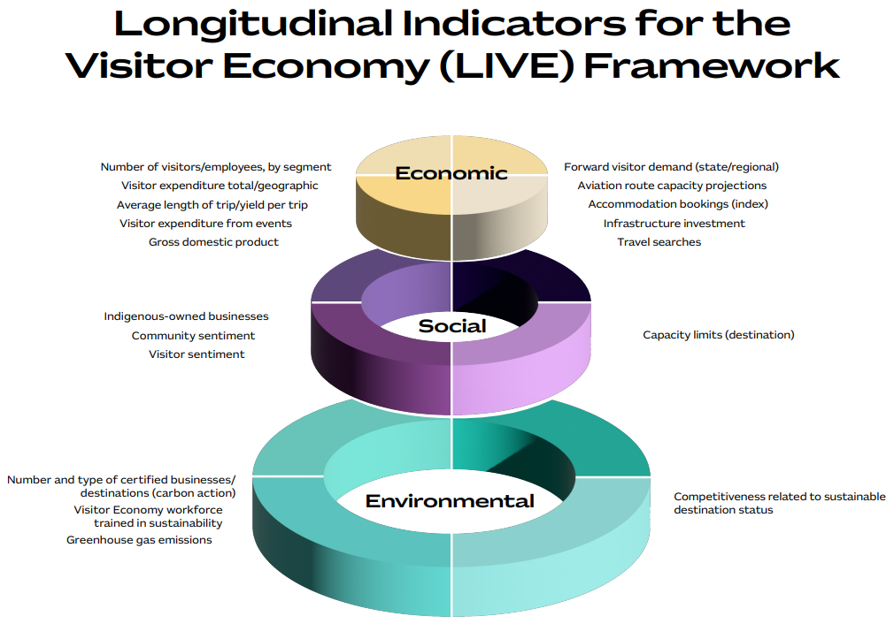

Attachment B
Changes resulting from Meeting 7, with additions bolded and deletions crossed out.
Economic indicators
Priority | Indicator
High | Aviation route capacity (seats available, movements)
 | Airports beyond gateways
 | Number of visitors total
 | Number of visitors by segment (by visa type, purpose, source market, etc.)
 | Forward visitor demand - Forward bookings and searches, consumer awareness, consideration and intention to visit, and lead time for destination choice and booking
 | Average length of stay/yield, per trip and per stay
 | Spatial movement of visitors (dispersal and mobility)
 | Visitor expenditure total and regional (domestic/international and daytrip/overnight)
 | Visitor expenditure from events (sporting, cultural and business events)
 | Distribution of yield: geography, seasonality
 | Gross domestic product (%) / gross value added
 | Share of global tourism expenditure (competitiveness)
 | Number of people employed in the visitor economy, FT/PT, quality of jobs
 | Labour productivity
 | Capital productivity
 | Share of voice (brand health) global position
Medium | Skills and training level of the visitor economy workforce
 | Number of tourism, hospitality and event graduates (total and by level of qualification)
 | Percentage of women in visitor economy workforce (and level of occupation)
 | Other job vacancies, domestic prep, tracking
 | Number of visitor economy businesses (by size)
 | Visitor economy business entries and exits
 | First Nations participation in the visitor economy workforce
 | Number of First Nations visitor economy businesses
 | Business investment and innovation (apart from infrastructure)
 | Public and/or private sector visitor economy investment tracking/pipeline (infrastructure)
 | New visitor economy experiences and products (including First Nations)
 | Available inventory / visitor demand
 | Accommodation establishments and rooms (including mainstream and sharing economy)
 | Accommodation rates for mainstream (incl. average daily room rate (ADRR), revenue per available room (RevPAR)) and average length of stay (ALOS)
 | Tourism transport mix
Low | Visitors seeking health and medical assistance
 | Cruise ports (ship visits, mobility mapping, disembarkment of visitors)
 | Government and industry collaboration to deliver THRIVE 2030
 | Open data
 | Competitive digital capability (test integration, 5G network, data, interparty)
 | Business event data gap — convention centre occupancy
 | Data security, privacy
 | Innovation (e.g. start-up activity)

Social indicators
Priority | Indicator
High | Visitor sentiment (quality of experience)
 | Community sentiment (social licence) (engagement)
 | Quality of life (residence)
 | Community support for tourism (includes events and extends to infrastructure)
 | Indigenous owned businesses
 | Cultural heritage protection (tangible and intangible)
 | Capacity limits / demand management / visitor contribution to life in Australia
 | Accessibility for people with physical disabilities (number and type of offering)
Medium | Accessibility for people with physical disabilities (number and type of offering)
 | Diversity of tourism organisation boards (age, gender, ethnicity, etc.)
Low | Homelessness in the destination
 | Crime against visitors
 | Crime by visitors
 | Percentage of women as CEO of tourism organisations
 | Staff wellbeing (relates to retention)

Environmental indicators
Priority | Indicator
High | Competitiveness of sustainable destination status (potentially use the World Economic Forum as a benchmark)
 | Visitor perception around environmental status of destination
 | Tourism $ contribution to nature conservation
 | Investment into protected areas and increases in infrastructure and park maintenance budgets
 | Greenhouse gas emissions (total / per visitor / per dollar)
 | Energy consumption per visitor
 | Water consumption per visitor
 | Digital environmental considerations
 | Commitments by businesses or states regarding carbon reduction targets
 | Certified businesses/destinations (e.g. carbon action)
 | Business adoption of sustainable quality control tools and accreditation
 | Visitor economy workforce trained in sustainability
Medium | Consumer sentiment towards nature conservation
 | Electric vehicle infrastructure
 | Pipeline of green technology and infrastructure
 | Volume of sustainable aviation fuel in the pipeline (production) / (% new aircraft)
 | Dispersal / spread of visitors
 | Visitor participation in nature-based experiences
 | Visitor contribution to regenerative activities
 | Indigenous perspective – connection to country caring for country
 | Consumer willingness to pay (for nature-based experiences and sustainability initiatives)
Low | Industry resilience (risk management, insurance and contingency plan readiness)
 | Insurance – share underinsured
 | Recovery time from a disaster event
 | Percentage of food sourced locally (within Australia and the local area)

Foundation indicators
Indicator
Competitive digital capability (test integration, 5G network, data, interparty)
Innovation
Resilience
THRIVE 2030 governance framework

